Website Blog Project

Author: Ce Guo (phoenix)
Update time: January 22, 2021

Website Blog Project 1
1. Requirements functional design 2
1.1 Project background 2
1.2 Functional design 3
2. Technical design 4
2.1 Architectural design 4
2.2 Development dependence 4
3. Database design 7
3.1 Logic design 7
3.2 DataTable design 7
4. Interface design 10
4.1 Server-side interface design 10
4.2 Browser-side interface design 11
5. Deployment design 13
5.1 Environment prepares 13

Requirements functional design

Project background
Develop an automatic assessment tool. It consists of two parts: formative assessment and summative assessment.
- Formative assessment:
including diagnostic tests, are designed to help students identify their strengths and weaknesses and target areas that require work. They provide immediate and continuous feedback that students can use to improve and staff can use to improve their teaching.
- Summative assessment:
refers to the evaluation of student learning at the end of the module / unit or theme or benchmark. Completion of the assessment will result in a score that will contribute to the final module score.

Functional design
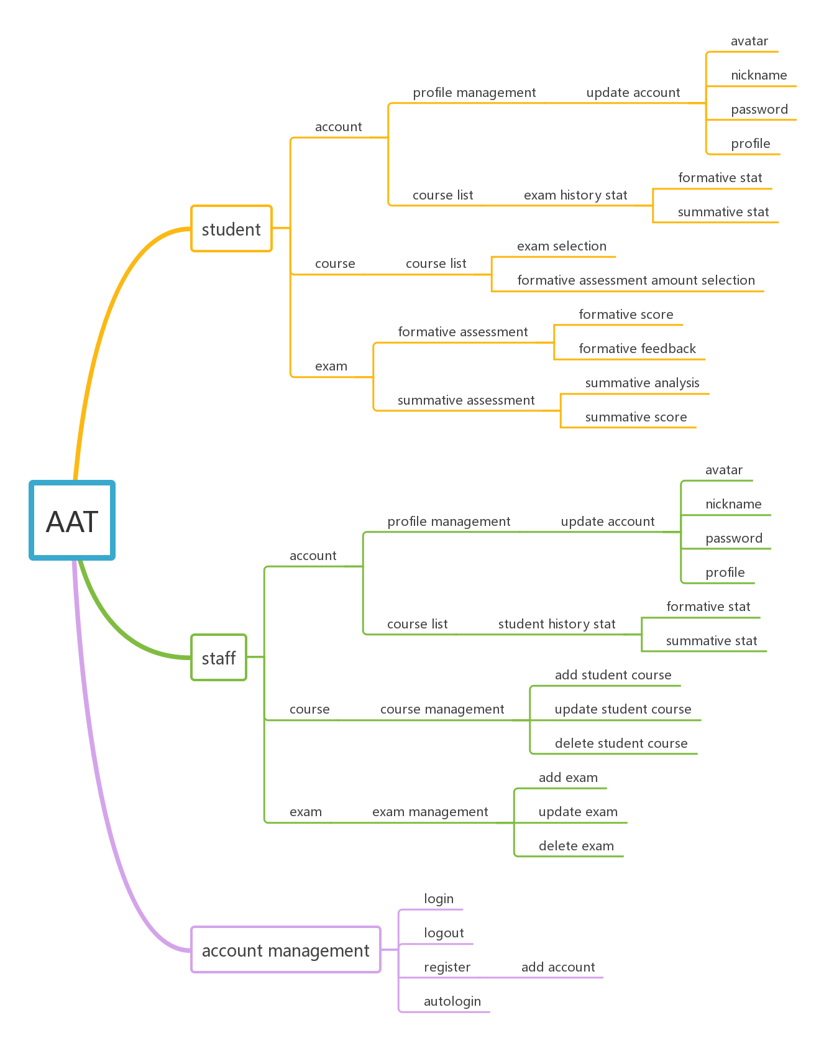

Technical design

Architectural design
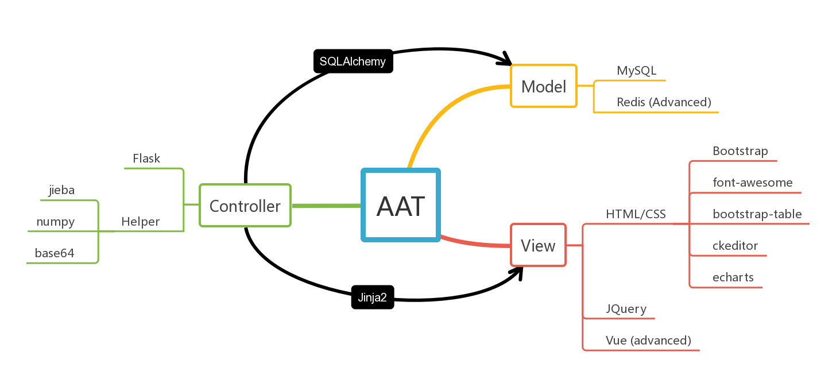

Development dependence
    - Server-side
Python 3.8
- pip install PyMySQL
Supports python operations on the database
- pip install SQLAlchemy
Support python ORM of database operations
- pip install Jinja2
Template engine supporting Flask rendering browser-side
- pip install Flask
Server-side framework
- pip install redis
Data cache server
- pip install numpy
Supports python operations on arrays and matrices
- pip install requests
Support python http requests
- pip install jieba
Support python separate words
    - Browser-side
- JQuery 3.5
Support Ajax request and DOM element operations
- Bootstrap 4
Support responsive design
- ckeditor
Support rich-text-editor
- font-awesome
Support icon and font resources
- bootstrap-table
Support table
- echarts
Support visualize charts
- Vue
Progressive framework that supports browser-server separation
- Chrome
Browser
    - Data-side
- MySQL 5.7
Database
- Redis 5
Data cache server
    - IDE
- PyCharm Professional
Integrated development environment of server-side
- VS code
Integrated development environment of browser-side
    - Debugging tool
- Postman
Interface debugging tool of server-side
- Debugger for Chrome (VS code)
Debugging tool of browser-side

Database design

Logic design
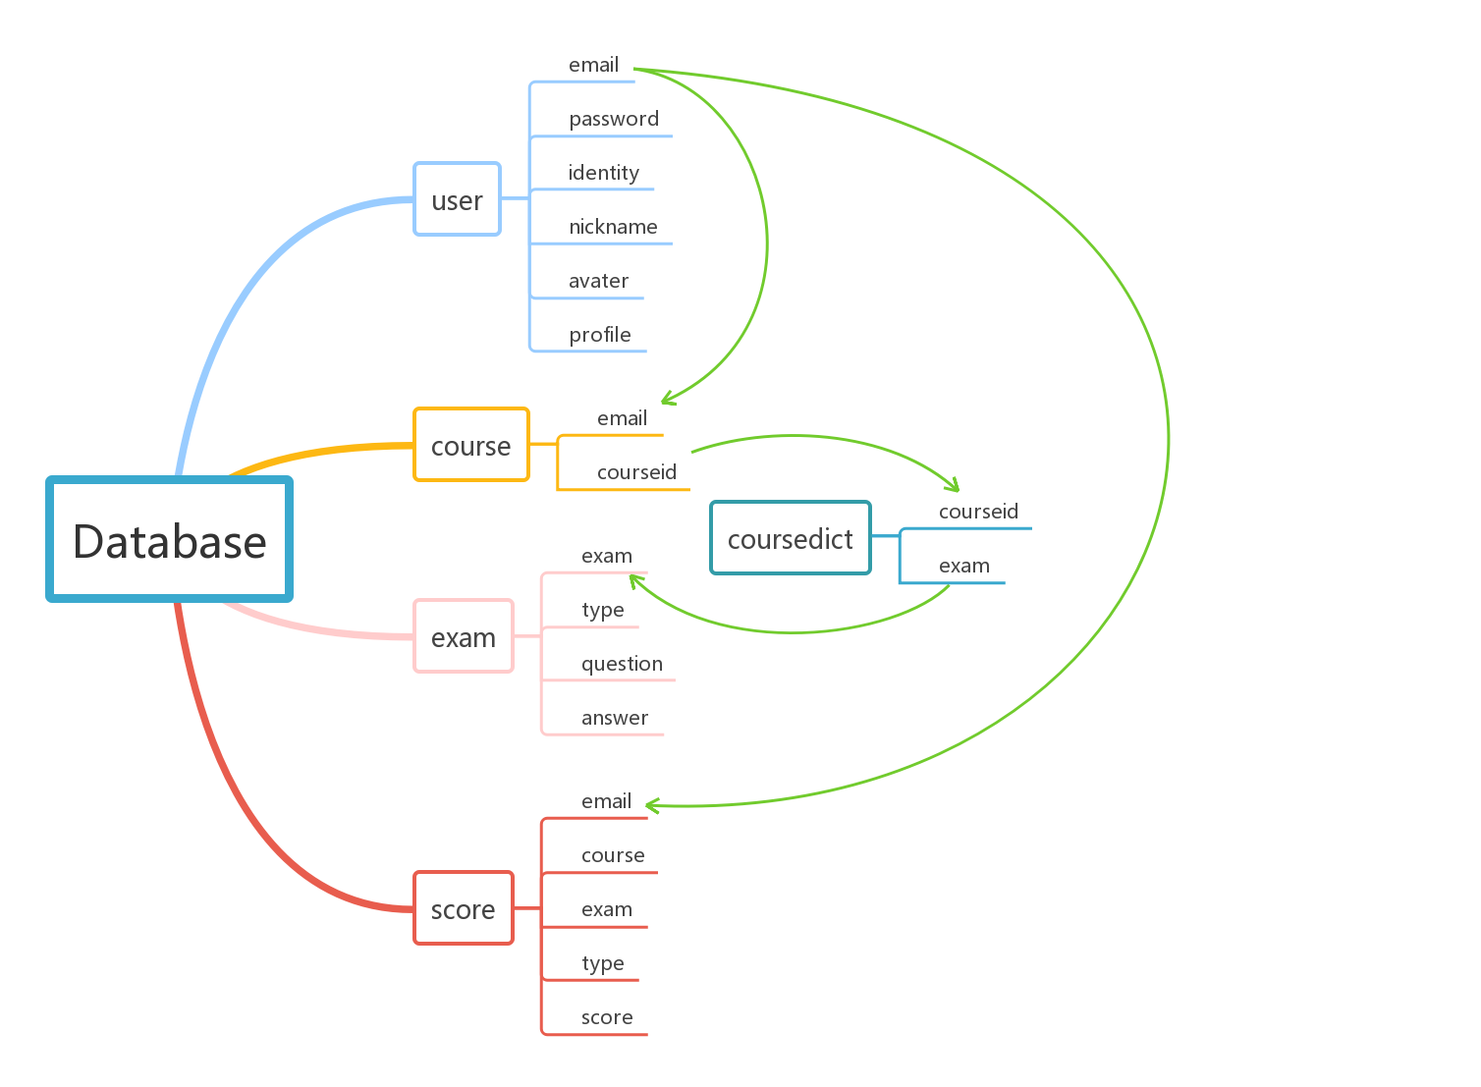

DataTable design
    - user
field | datatype | length | PK
id | int | 8 | √
email | varchar | 50
password | varchar | 50
identity | varchar | 10
nickname | varchar | 50
image | varchar | 100
profile | varchar | 255
time | datetime | 0
    - course
field | datatype | length | PK
id | int | 8 | √
email | varchar | 50
course | varchar | 50
time | datetime | 0
    - coursedict
field | datatype | length | PK
id | int | 8 | √
courseid | varchar | 50
course | varchar | 50
exam | varchar | 50
time | datetime | 0
    - exam
field | datatype | length | PK
id | int | 8 | √
exam | varchar | 50
type | varchar | 50
question | varchar | 255
answer | varchar | 255
time | datetime | 0
    - score
field | datatype | length | PK
id | int | 8 | √
email | varchar | 50
course | varchar | 50
exam | varchar | 50
type | varchar | 50
score | varchar | 50
time | datetime | 0

Interface design

Server-side interface design
    - Index
- @index.route('/')
Return home page
    - User
- @user.route('/login', methods=['POST'])
Interface of user login
- @user.route('/register', methods=['POST'])
Interface of user register
- @user.route('/logout')
Interface of user logout
    - Course
- @course.route('/course')
Return course page
- @course.route('/course/<courseid>/coursemanagement')
Interface of initial course management table for staff
- @course.route('/course/<courseid>/coursemanagementadddata', methods=['POST'])
Interface of adding data to database in course management
- @course.route('/course/<courseid>/coursemanagementupdatedata, methods=['POST'])
Interface of updating data to database in course management
- @course.route('/course/<courseid>/coursemanagementdeletedata, methods=['POST'])
Interface of deleting data in database in course management
    - Exam
- @exam.route('/course/<course>/<examname>')
Return exam page
- @exam.route('/course/<course>/<examname>/getformativeresult')
Interface of getting formative assessment score and feedback
- @exam.route('/course/<course>/<examname>/getsummativeresult')
Interface of getting summative assessment score and analysis
- @exam.route('/course/<course>/<examname>/exammanagement')
Interface of initial exam management table for staff
- @exam.route('/course/<course>/<examname>/exammanagementadddata', methods=['POST'])
Interface of adding data to database in exam management
- @exam.route('/course/<course>/<examname>/exammanagementupdatedata', methods=['POST'])
Interface of updating data to database in exam management
- @exam.route('/course/<course>/<examname>/exammanagementdeletedata', methods=['POST'])
Interface of deleting data in database in exam management
    - Account
- @account.route('/account')
Return account page
- @account.route('/account/updateprofile', methods=['POST'])
Interface of updating account profile
- @account.route('/account/<course>/getscorestat')
Interface of getting history score stat
- @account.route('/account/<course>/updatescorestat')
Interface of refreshing history score stat

Browser-side interface design
    - Index
- loginOrRegister()
Request login or register
    - Course
- GoExam(location)
Request exam page
- courseManagement(courseid)
Request course management table
- examManagement(courseid, examname)
Request exam management table
- addTableData(courseid, examname)
Request add data to database
- updateTableData(courseid, examname)
Request update data to database
- deleteTableData(courseid, examname)
Request delete data in database
    - Exam
- ShowFormativeScoreAndFeedback()
Requset show formative score and feedback charts
- ShowSummativeScore()
Requset show summative score and analysis charts
    - Account
- UpdateProfile()
Request update account profile to database
- ShowScoreStat(element, identity)
Request show history score stat
- UpdateScoreStat(element, identity)
Request refresh history score stat

Deployment design
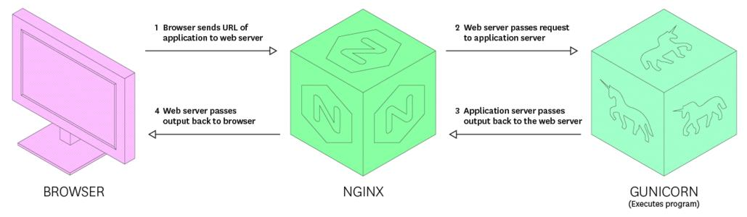
Ubuntu 16.04 as server system, nginx as http server, gunicorn as Python WSGI HTTP server.

Environment prepares
    - Python environment install
- sudo su root
Switch to root account
- sudo apt-get update
Update server resources
- mkdir /usr/local/software
Create a software installation package folder
- cd /usr/local/software
Enter the Software Installation Package folder
- sudo apt-get install zlib1g-dev libbz2-dev libssl-dev libncurses5-dev libsqlite3-dev
Configuration dependency
- wget https://www.python.org/ftp/python/3.8.6/Python-3.8.6.tar
Download python3.8.6
- mkdir /usr/local/python3.8
Create python folder
- tar -zxvf Python-3.8.6.tgz
Unzip the package
- cd Python-3.8.6
Enter the extracted folder
- ./configure --prefix=/usr/local/python3.8
Compile python to the folder you just created
- make && make install
Install python
- ln -sf /usr/local/python3.8/bin/* /usr/local/bin/
Building python3 soft chains
- vim ~/.bash_profile
open the bash_profile file and add the following code to the end of the file
PATH=$PATH:$HOME/bin:/usr/local/python3.8/bin
export PATH
Press ESC, Enter :wq to exit
- source ~/.bash_profile
Execute file
- python3 -V
Check python3 version
- pip3 -V
Check pip3 version
    - Virtual environment install
- sudo apt-get install mysql-server
Install mysql
- sudo apt-get install libmysqlclient-dev
Install mysql client
- sudo apt-get install redis-server
Install redis cache server
- mkdir /~/.virtualenvs
Create. virtualenvs folder
- sudo pip3 install -U --force-reinstall pip
Compulsory update pip3
- sudo pip3 install virtualenv
Install virtualenv
- sudo pip3 install -i https://pypi.tuna.tsinghua.edu.cn/simple --trusted-host pypi.tuna.tsinghua.edu.cn pbr
Install pbr
- sudo pip3 install virtualenvwrapper
Install virtualenvwrapper
- vim ~/.bashrc
Open the bashrc file and add the following code to the end
VIRTUALENVWRAPPER_PYTHON=/usr/local/python3.8/bin/python3
export WORKON_HOME=$HOME/.virtualenvs
export PROJECT_HOME=$HOME/workspace
source /usr/local/python3.8/bin/python3/virtualenvwrapper.sh
Press ESC, Enter :wq to exit
- source ~/.bashrc
Execute file
- mkvirtualenv -p python3 flask_AAT
Create virtual environments
- workon flask_AAT
Access to virtual environments
- sudo pip3 install -r requirements.txt
Installation project dependency library
    - Nginx environment install
- sudo apt-get install nginx
Install nginx
- vim /etc/nginx/sites-available/default
Enter the default file and modify the following
upstream flask {
server 127.0.0.1:5000;
}
server {
listen 80 default_server;
listen [::]:80 default_server;
root /var/www/html;
index index.html index.htm index.nginx-debian.html;
server_name _ phx.gold;
location / {
proxy_pass http://127.0.0.1:5000;
proxy_set_header Host $host;
proxy_set_header X-Real-IP $remote_addr;
}
}
Press ESC, Enter :wq to exit
- /etc/init.d/nginx start
Testing nginx services
- ps -ef | grep nginx
Find nginx process number
- kill -HUP xxxx
Restart nginx services
    - Gunicorn environment install
- sudo pip3 install gunicorn
Install gunicorn
- pstree -ap|grep gunicorn
Check gunicorn tree
- gunicorn -b 127.0.0.1:5000 --workers=4 --access-logfile logs/gunicorn-access.log --error-logfile logs/gunicorn-error.log --log-level=warning main:app
Start gunicorn
- kill -HUP xxxx
Restart gunicorn
- kill -9 xxxx
Close gunicorn
    - Mysql environment config
- select @@global.sql_mode;
Check global.sql_mode
- set @@global.sql_mode = 'STRICT_TRANS_TABLES,NO_ZERO_IN_DATE,NO_ZERO_DATE,ERROR_FOR_DIVISION_BY_ZERO,NO_AUTO_CREATE_USER,NO_ENGINE_SUBSTITUTION';
Set global.sql_mode
- select @@sql_mode;
Check sql_mode
- set @@sql_mode = 'STRICT_TRANS_TABLES,NO_ZERO_IN_DATE,NO_ZERO_DATE,ERROR_FOR_DIVISION_BY_ZERO,NO_AUTO_CREATE_USER,NO_ENGINE_SUBSTITUTION'
Set sql_mode

